How has FAITH influenced my professional life? 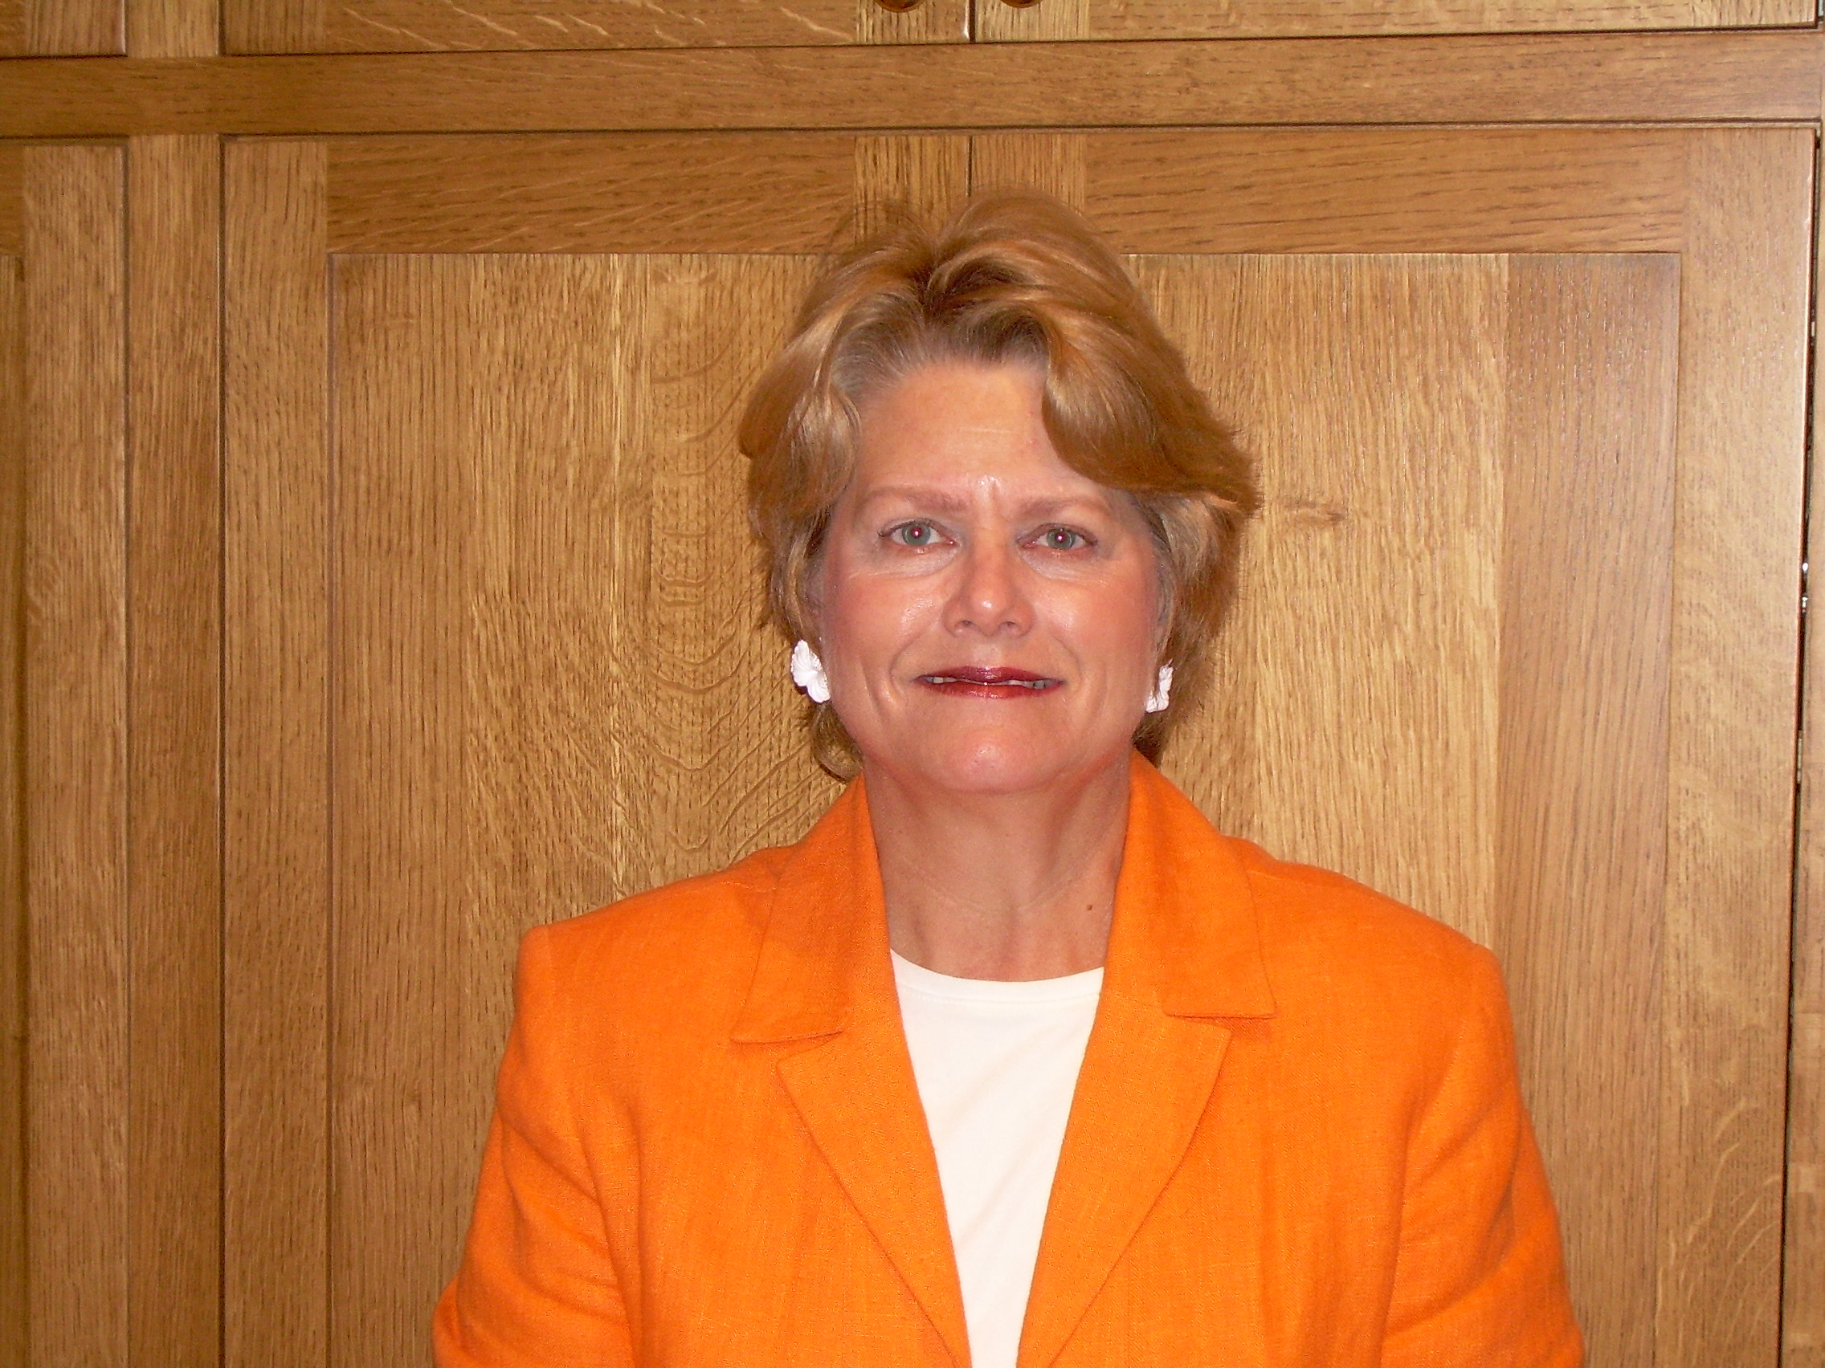

Carole A. Bagley, Ph.D.

The book of Genesis calls upon each of us to “subdue the world” and we are called through our labor to share in the work of creation and to contribute to the realization of the divine plan.

In 25.Work as a Sharing in the Activity of the Creator from the Encyclical Letter of John Paul II “On Human Work”, Laborem Exercens, John Paul II writes:
Awareness that man's work is a participation in God's activity ought to permeate even "the most ordinary everyday activities”. For, while providing the substance of life for themselves and their families, men and women are performing activities in a way which appropriately benefits society.

Faith has been a cornerstone in my professional and personal life as I reach to fulfill three life-long goals:
- LOVE what I do because I have been “CALLED” to perform this work
- Make a difference in the world as it benefits society
- Maintain balance in life

Without faith, I could never have succeeded in a male dominated profession of geeky computer technologists. Innovation, change and exciting work are important to me in my work life. I have worked as an employee in the corporate and government sectors, as a university professor and as an entrepreneur in founding and continuing to run a technology and learning business. I have experienced challenges, however, I LOVE my work and I have made a difference! In addition to corporate work, I have been able to bring technology into many non-profits including: correctional institutions, Armed Forces, Goodwill, Salvation Army, schools and others, some of which have been donated services.
If one takes notice of the people around you, it becomes clear that passion and meaning together with talent and environment are important parts of any “calling”. LISTEN. God has a plan for us and we are called to fulfill it. I use the phrase “If the words do not come out, God has not meant it to be”. If a work relationship does not work out for an undefined reason, it is not meant to be. LISTEN. Do not excuse yourself from working hard, but realize that some things are not to be.
I am currently involved in teaching and developing UST students and in directing a $4M inter-agency e-Learning project with the Army, Navy, Air Force, Coast Guard and VA. I love the collaboration among people and the innovation in the work. I relish the difference I am able to make in assisting UST learners in their growth and in assisting our Armed Forces to provide e-Learning around the world.
The world can be a trying place. With the turmoil in the world from 9/11 and the war in Iraq and with all the choices to make, one can be fearful of making a mistake. If one LISTENS, there should be no fear, since life is a journey and new windows will be opened as doors close. I have experienced this. Do not be afraid! LISTEN! Have faith!
Support for balance in life and harmony between work and what is good for the human race, we are cautioned that nothing will be gained without balance in 27. Human Work in the Light of the Cross. “Therefore, while we are warned that it profits a man nothing if he gains the whole world and loses himself”.
Consider that 52% of full-time workers today indicate a desire to change jobs. 86% cite fulfillment and work/life balance as their top career priority. Further, 96% are attracted to employers who offer ways for them to make time for personal responsibilities and 73% of employees said they are willing to curtail their careers to make time for family.
For those who have not yet identified their life's work, "Discover What Gives Your Life Meaning and Purpose" should be among the requirements for an undergraduate degree. Throughout life, LISTEN to God’s “calling” and maintain balance, because only then will you and your family survive and YOU will be able to truly benefit society!

